**MSc Project Plan**

**CSC-40040**

### Project Overview and Description

**Student Name: Timothy Kipkoech Singen**

**Student Username: y3V53**

**Student Number: 24021762**

**Degree Title: MSc Artificial Intelligence and Data Science**

**Supervisor Name:**  Dr Aisha Junejo

**Project Title:**  Anomaly detection for Next Generation Supply Chain and Logistics.

**Please provide a brief Project Description:**

|  |
| --- |
| The project leverages advanced techniques and technology used in anomaly detection in the next-generation supply chain and logistics system. This is to enhance reliability, efficiency and to combat unexpected events like inventory mismatches and fraudulent activities that could disrupt operations. |

**What are the aims and objectives of the Project?**

|  |
| --- |
| 1. Improve efficiency by identifying anomalies in real-time across all logistics operations like transportation, supply operations and warehousing. 2. Create predictive models that adapt to dynamic conditions. 3. Reduce waste due to cost incurred during delivery rerouting and disruptions. |

**Please provide a brief overview of the key literature related to the Project:**

|  |
| --- |
| 1. **Chandola et al. (2009) – "Anomaly Detection: A Survey"**  This foundational paper offers a comprehensive survey of anomaly detection techniques, categorizing them into statistical, proximity-based, and machine learning methods. 2. **Zhang et al. (2019) – "A Machine Learning Approach for Anomaly Detection in Supply Chain Operations"**  This study applies machine learning models to detect anomalies in warehouse and transportation data. 3. **Kumar et al. (2022) – "AI-Based Predictive Maintenance and Anomaly Detection in Smart Logistics"**  This paper presents a practical implementation of AI for anomaly detection in logistics fleets and warehouse systems, emphasizing IoT integration and real-time monitoring to support proactive decision-making in next-generation logistics. |

### Project Processes and Methods

**Please provide a brief overview of the Methodology to be used in the Project (inc. an overview of best practice within the Methodology):**

|  |
| --- |
| * Exploratory data Analysis will be used to identify potential anomalies using statistical techniques. * Implement real-time monitoring and precision models to trigger outlier alerts. * Create visualization reports for action insights to the managers. |

**Will any special Data Collection Methods be employed (e.g card sorts, questionnaires, simulations, …)?**

|  |
| --- |
| Gather unstructured data from logistics systems. |

**Please describe what skills you have learnt during your course that you will need to use during your project. Also describe which skills you will need to develop in order to successfully complete your project.**

|  |
| --- |
| I learnt Python programming**,** Libraries & Frameworks. I am planning to use them during my project and also incorporate Big data tools and Visualization. |

### Time and Resource Planning

**Will Standard Departmental Hardware be used?** YES/NO

**If NO please outline the Hardware/Materials to be used:**

|  |
| --- |
| Yes. |

**Will Software which is already available in the department be used?** YES/NO

**If NO please outline the Software to be used including how any necessary licences will be obtained:**

|  |
| --- |
| Yes. |

**Will the project require any Programming?** YES/NO

**If YES please list the (potential) Programming Languages to be used (including any IDEs and Libraries you may make use of):**

|  |
| --- |
| Yes. Python Programming. Pandas, NumPy, Matplotlib, Seaborn. |

**Table of Risks (*if non Standard Hardware and/or Software to be used please also include backup options/ contingency plans here)*:**

|  |  |  |  |
| --- | --- | --- | --- |
| **Risk-id**  **Description** | **Probability/Likelihood of occurring** | **Best practice prevention measures** | **Remedy** |
|  |  |  |  |
|  |  |  |  |
|  |  |  |  |
|  |  |  |  |

**Gantt Chart (must include milestones and deliverables):**

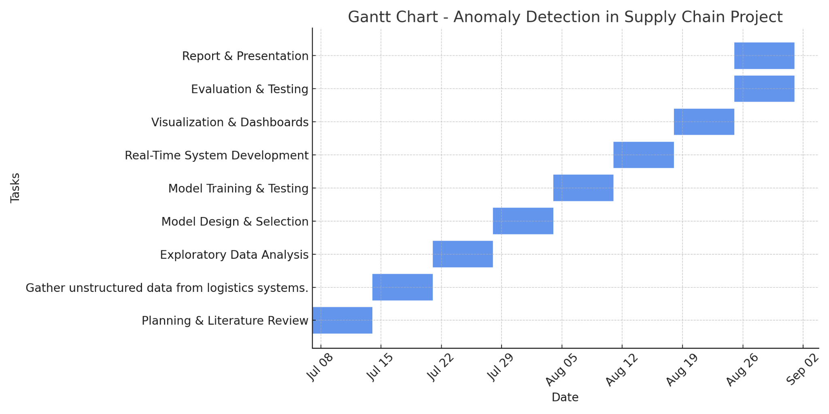

### References

**Please include a list of References used in this Plan (using Harvard reference style):**

|  |
| --- |
| Chandola, V., Banerjee, A. and Kumar, V., 2009. Anomaly detection: A survey. *ACM Computing Surveys*, 41(3), pp.1-58.  <https://doi.org/10.1145/1541880.1541882>    Zhang, Y., Ren, S., Liu, Y. and Si, S., 2019. A big data analytics architecture for cleaner manufacturing and maintenance processes of complex products. *Journal of Cleaner Production*, 265, p.121383.  <https://doi.org/10.1016/j.jclepro.2019.121383>  Kumar, A., Luthra, S., Mangla, S.K. and Kazancoglu, Y., 2022. AI-based predictive maintenance and anomaly detection in smart logistics: Current trends and future directions. *Technological Forecasting and Social Change*, 175, p.121339.  <https://doi.org/10.1016/j.techfore.2021.121339> |

**Submission Date: 7/9/2025**

**PLEASE NOTE THAT SHOULD YOUR PROJECT UNDERGO ANY MAJOR CHANGES FOLLOWING THE SUBMISSION OF THIS PLAN YOU ARE EXPECTED TO SUBMIT AN UPDATED PLAN WHICH ACCURATELY REFLECTS YOUR PROJECT.**